PRACTICAL 1

AIM - To perform vector operations.

PROBLEM - Define a vector of decimal data whose elements are 3.357, 1.256, 2.198, 0.123, 4.132, 7.313, 0.123, 4.103, 3.293 and perform the following tasks.
- Check the length of the vector and also convert its elements to 2 decimal places.
- Extract the 4th and 2nd elements.
- Extract all those entries whose values are greater than 2.
- Check whether it’s a numeric vector, integer vector or character vector.
- Calculate the square root and natural log of each entry.
- Convert these vectors to character and integer vector. Thereafter perform the checking by using testing function available in R.
- Name the vector elements as x1, x2, x3, …
- By using the names, subset the vector for the values of x3, x6 and x7.

THEORY & METHODOLOGY USED - To check the length of a vector, i.e, number of elements in a vector, length() function is used. is.numeric() function is used to check if a vector is numeric or not. Similarly, we can check for an integer or character vector. sqrt() and log() functions are used to find the square root and natural log of vector elements respectively. To convert, say, a numeric vector into a character vector, we use as.character() function.
CODE & OUTPUT -
> #Defining a vector of decimal data.
> x=c(3.357,1.256,2.198,0.123,4.132,7.313,0.123,4.103,3.293)
> x
[1] 3.357 1.256 2.198 0.123 4.132 7.313 0.123 4.103 3.293

1) > #Checking the length of the vector and converting its elements to 2 decimal places.
> length(x)
[1] 9
> x=round(x,digits=2)
> x
[1] 3.36 1.26 2.20 0.12 4.13 7.31 0.12 4.10 3.29

2) > #Extracting the 4th and 2nd element.
> x[4]
[1] 0.12
> x[2]
[1] 1.26

3) > #Extracting the elements greater than 2.
> x[x>2]
[1] 3.36 2.20 4.13 7.31 4.10 3.29

4) > #Checking whether it's a numeric, integer or character vector.
> is.numeric(x)
[1] TRUE
> is.integer(x)
[1] FALSE
> is.character(x)
[1] FALSE

5) > #Calculating the square root and natural log of elements.
> sqrt(x)
[1] 1.8330303 1.1224972 1.4832397 0.3464102 2.0322401 2.7037012 0.3464102
[8] 2.0248457 1.8138357
> log(x)
[1] 1.2119410 0.2311117 0.7884574 -2.1202635 1.4182774 1.9892433 -2.1202635
[8] 1.4109870 1.1908876

6) > #Converting the vector to a character and integer vector and checking them using testing function.
> y=as.character(x)
> y
[1] "3.36" "1.26" "2.2" "0.12" "4.13" "7.31" "0.12" "4.1" "3.29"
> is.character(y)
[1] TRUE
> z=as.integer(x)
> z
[1] 3 1 2 0 4 7 0 4 3
> is.integer(z)
[1] TRUE

7) > #Naming the vector elements.
> names(x)=c("x1","x2","x3","x4","x5","x6","x7","x8","x9")
> names(x)
[1] "x1" "x2" "x3" "x4" "x5" "x6" "x7" "x8" "x9"
> x
x1 x2 x3 x4 x5 x6 x7 x8 x9
3.36 1.26 2.20 0.12 4.13 7.31 0.12 4.10 3.29

8) > #Subsetting the vector using the names.
> m=x[c("x3","x6","x7")]
> m
x3 x6 x7
2.20 7.31 0.12

RESULT -
- Length of the vector or number of the vector elements = 9.
- 4th element = 0.12 and 2nd element = 1.26
- The given vector is a numeric vector.

PRACTICAL – 2

AIM - To perform vector operations.
PROBLEM - Generate a vector of 20 elements starting with 2.5 by a jump of 0.3 and perform the following tasks :-
- Check the class and type of this vector.
- Convert this to complex vector and save with a name.
- Extract all the elements of the original vector which are at the even places.
- Extract the 1st 5 elements of original vector. Therefore, bind them row-wise and column-wise and store under the name row_mat and col_mat. Perform the testing for matrix and vector.

THEORY & METHODOLOGY USED - We use the functions class() and typeof() to check the class and type of the vector respectively. We can convert this vector to a complex vector by using as.complex() function. To extract the vector elements at even places we make use of ‘for’ loop. rbind()/cbind() function is used to convert a vector into rows/columns of a matrix respectively.

CODE & OUTPUT -
> #Generating a vector of 20 elements starting with 2.5 by a jump of 0.3.
> x=seq(from=2.5,by=0.3,length.out=20)
> x
[1] 2.5 2.8 3.1 3.4 3.7 4.0 4.3 4.6 4.9 5.2 5.5 5.8 6.1 6.4 6.7 7.0 7.3 7.6 7.9
[20] 8.2

1) > #Checking the class and type of vector.
> class(x)
[1] "numeric"
> typeof(x)
[1] "double"

2) > #Converting it to complex vector and saving with a name.
> comp=as.complex(x)
> comp
[1] 2.5+0i 2.8+0i 3.1+0i 3.4+0i 3.7+0i 4.0+0i 4.3+0i 4.6+0i 4.9+0i 5.2+0i
[11] 5.5+0i 5.8+0i 6.1+0i 6.4+0i 6.7+0i 7.0+0i 7.3+0i 7.6+0i 7.9+0i 8.2+0i

3) > #Extracting the elements at even places of original vector.
> for(i in 1:length(x))
+ {
+ if(i%%2==0)
+ print(x[i])
+ }
[1] 2.8
[1] 3.4
[1] 4
[1] 4.6
[1] 5.2
[1] 5.8
[1] 6.4
[1] 7
[1] 7.6
[1] 8.2

4) > #Extracting the 1st 5 elements of original vector, binding them row and column wise and performing the testing on them.
> y=x[c(1,2,3,4,5)]
> y
[1] 2.5 2.8 3.1 3.4 3.7
> row_mat=rbind(y)
> row_mat
[,1] [,2] [,3] [,4] [,5]
y 2.5 2.8 3.1 3.4 3.7
> col_mat=cbind(y)
> col_mat
y
[1,] 2.5
[2,] 2.8
[3,] 3.1
[4,] 3.4
[5,] 3.7
> is.matrix(row_mat)
[1] TRUE
> is.vector(row_mat)
[1] FALSE
> is.matrix(col_mat)
[1] TRUE
> is.vector(col_mat)
[1] FALSE

RESULT -
- Class of the given vector is ‘numeric’ and type of the given vector is ‘double’.
- It is verified that after using rbind()/cbind() function on the given vector and thereafter applying testing function, its identity is coming out to be a matrix and not a vector

PRACTICAL – 3

AIM - To perform vector operations.
PROBLEM - Generate one vector of size n=5 of 2s and second vector of size m=4 of 5s and perform the following tasks:
- Combine them into a single vector.
- Add an element to original vector whose value is 3 & store them under the name value.
- Extract all the elements which are at the odd places.
THEORY & METHODOLOGY USED - rep() function is used to generate a vector containing same elements. To add an element to the vector, append() function is used which appends the additional element to the end of the vector. ‘for’ loop is to be used while extracting elements at odd places.
CODE & OUTPUT -
> #Generating 2 vectors of 2's and 5's.
> x=rep(2,times=5)
> x
[1] 2 2 2 2 2
> y=rep(5,times=4)
> y
[1] 5 5 5 5

(i) > #Combining them into a single vector.
> z=c(x,y)
> z
[1] 2 2 2 2 2 5 5 5 5

(ii) > #Adding an element to the vector and giving it a name.
> value=append(z,3)
> value
[1] 2 2 2 2 2 5 5 5 5 3

(iii) > #Extracting the elements at the odd places.
> for(i in 1:length(value))
+ {
+ if(i%%2!=0)
+ print(value[i])
+ }
[1] 2
[1] 2
[1] 2
[1] 5
[1] 5

RESULT - After combining the original vectors into a single vector named ‘value’ and inserting an additional element to it, the elements obtained which are at the odd places are: 2,2,2,5,5.

PRACTICAL – 4

AIM - To perform operations on a complex vector.
PROBLEM - Define a vector of the complex numbers whose elements are 1+2i, 4-1i, 2+1i, 2-2i, 5-1i, 3+6i and perform the following tasks:
- Extract the real and imaginary part of the above vector.
- Calculate the modulus and complex conjugate of the above vector.
- Check the type and class of this vector. Also use str() function to get the full details of this vector.
THEORY & METHODOLOGY USED - A complex number is defined as z=a+bi where the real number ‘a’ is called the real part of the complex number and the real number ‘b’ is called the imaginary part of the complex number. Modulus of z is given by $z=\sqrt{a^{2}+b^{2}}$ where, z=a+bi and its complex conjugate will be defined as z’=a-bi.
CODE & OUTPUT -
> #Defining a vector of complex numbers.
> x=c(1+2i,4-1i,2+1i,2-2i,5-1i,3+6i)
> x
[1] 1+2i 4-1i 2+1i 2-2i 5-1i 3+6i

(i) > #Extracting the real and imaginary part of the vector.
> Re(x)
[1] 1 4 2 2 5 3
> Im(x)
[1] 2 -1 1 -2 -1 6

(ii) > #Calculating the modulus and complex conjugate of the vector.
> Mod(x)
[1] 2.236068 4.123106 2.236068 2.828427 5.099020 6.708204
> Conj(x)
[1] 1-2i 4+1i 2-1i 2+2i 5+1i 3-6i

(iii) > #Checking the type and class of vector and using str() function for full details of the vector.
> typeof(x)
[1] "complex"
> class(x)
[1] "complex"
> str(x)
cplx [1:6] 1+2i 4-1i 2+1i ...

RESULT - Real & imaginary parts, modulus and complex conjugates of the elements of the vector are displayed in the output. Type and class of the given vector is ‘complex’.

PRACTICAL – 5

AIM - To perform matrix operations and extraction of elements.
PROBLEM - Define the following matrix with name mat_A in R:
$mat__A=\left(5.07 3.19 1.21 8.95 2.32 1.87 -2.04 4.49 -3.22 -4.66 1.18 6.72 9.93 2.05 -3.66 8.77 \right)$
- Print the number of rows, columns and dimensions of the above matrix.
- Calculate the transpose, inverse, row sum, column sum, row mean, column mean
- Use R function to print the diagonal of mat_A.
- Extract second column of mat_A.
- Extract 3rd row of mat_A.
- Extract the 4th entry of the 3rd column of mat_A.
- Define the row names as : R1, R2, R3, R4.
- Also define the column names as : C1, C2, C3, C4.

THEORY & METHODOLOGY USED - Dimensions of a matrix is represented as no. of rows x no. of columns, i.e., 2x2, 3x3, …. Transpose of a matrix A is given by A’ where rows of A become columns of A’ and vice versa. Inverse of a matrix A is given by A⁻¹ such that AA⁻¹=I, where I is an identity matrix of same order as of A. Inverse can be calculated only for square matrices and only when a matrix is non-singular, i.e., when det (A) is not equal to 0.
CODE & OUTPUT -
> data=c(5.07,3.19,2.32,1.87,1.21,8.95,-2.04,4.49,-3.22,-4.66,9.93,2.05,1.18,6.72,-3.66,8.77)
> mat_A=matrix(data,nrow=4,ncol=4,byrow=TRUE)
> mat_A

(i) > #Printing the no. of rows,columns and dimensions of the matrix.
> nrow(mat_A)
[1] 4
> ncol(mat_A)
[1] 4
> dim(mat_A)
[1] 4 4

(ii) > #Calculating the transpose, inverse, row sum, column sum, row mean and column mean of the matrix.
> t(mat_A)
[,1] [,2] [,3] [,4]
[1,] 5.07 1.21 -3.22 1.18
[2,] 3.19 8.95 -4.66 6.72
[3,] 2.32 -2.04 9.93 -3.66
[4,] 1.87 4.49 2.05 8.77
> solve(mat_A)
[,1] [,2] [,3] [,4]
[1,] 0.183099990 -0.12001015 -0.054483036 0.03513556
[2,] -0.018670396 0.19695919 0.008401683 -0.09882059
[3,] 0.048560816 0.07488557 0.079911327 -0.06737322
[4,] 0.009936107 -0.10352025 0.034242432 0.15690176
> rowSums(mat_A)
[1] 12.45 12.61 4.10 13.01
> colSums(mat_A)
[1] 4.24 14.20 6.55 17.18
> rowMeans(mat_A)
[1] 3.1125 3.1525 1.0250 3.2525
> colMeans(mat_A)
[1] 1.0600 3.5500 1.6375 4.2950

(iii) > #Printing the diagonal of a matrix.
> diag(mat_A)
[1] 5.07 8.95 9.93 8.77

(iv) > #Extracting second column of the matrix.
> mat_A[,2]
[1] 3.19 8.95 -4.66 6.72

(v) > #Extracting third row of the matrix.
> mat_A[3,]
[1] -3.22 -4.66 9.93 2.05

(vi) > #Extracting 4th entry of third column from a matrix.
> mat_A[4,3]
[1] -3.66

(vii) > #Defining the row names for a matrix.
> rownames(mat_A)=c("R1","R2","R3","R4")

(viii) > #Defining the column names for a matrix.
> colnames(mat_A)=c("C1","C2","C3","C4")
> mat_A
C1 C2 C3 C4
R1 5.07 3.19 2.32 1.87
R2 1.21 8.95 -2.04 4.49
R3 -3.22 -4.66 9.93 2.05
R4 1.18 6.72 -3.66 8.77

RESULT -
- No. of rows in the given matrix = 4, No. of columns in the given matrix = 4, Dimensions of the given matrix = 4x4.
- Transpose and inverse of the matrix are calculated in the output using t() and solve() functions respectively.
- Diagonal elements of the given matrix are: 5.07, 8.95, 9.93, 8.77.

PRACTICAL – 6

AIM - To perform matrix operations.
PROBLEM - Generate 2 sequences each of size 25 starting with 1 by a jump of 0.15 and 0.45 respectively. Using these 2 sequences, make 2 matrices of order 5x5 with name mat_B and mat_C respectively.
- Perform addition, subtraction and multiplication with the above 2 matrices.
- Extract 1st, 3rd and 5th columns of mat_B and store under the name mat_D.
- Combine 5th columns of mat_B and mat_C.
- Combine mat_B and mat_C row-wise and column-wise.

THEORY & METHODOLOGY USED - Suppose we have 2 matrices of order 2x2 where,
$A=\left(a b c d \right)$ and $B=\left(p q r s \right)$
Then, $A+B=\left(a+p b+q c+r d+s \right)$
$A-B=\left(a-p b-q c-r d-s \right)$
$A*B=\left(a*p+b*r a*q+b*s c*p+d*r c*q+d*s \right)$
Also, we use rbind() and cbind() functions to combine the matrices row-wise and column-wise respectively.

CODE & OUTPUT –
> a=seq(from=1,by=0.15,length.out=25)
> a
[1] 1.00 1.15 1.30 1.45 1.60 1.75 1.90 2.05 2.20 2.35 2.50 2.65 2.80 2.95 3.10
[16] 3.25 3.40 3.55 3.70 3.85 4.00 4.15 4.30 4.45 4.60
> b=seq(from=1,by=0.45,length.out=25)
> b
[1] 1.00 1.45 1.90 2.35 2.80 3.25 3.70 4.15 4.60 5.05 5.50 5.95
[13] 6.40 6.85 7.30 7.75 8.20 8.65 9.10 9.55 10.00 10.45 10.90 11.35
[25] 11.80
> #Making matrices out of the sequences generated.
> mat_B=matrix(a,nrow=5,ncol=5,byrow=TRUE)
> mat_B
[,1] [,2] [,3] [,4] [,5]
[1,] 1.00 1.15 1.30 1.45 1.60
[2,] 1.75 1.90 2.05 2.20 2.35
[3,] 2.50 2.65 2.80 2.95 3.10
[4,] 3.25 3.40 3.55 3.70 3.85
[5,] 4.00 4.15 4.30 4.45 4.60
> mat_C=matrix(b,nrow=5,ncol=5,byrow=TRUE)
> mat_C
[,1] [,2] [,3] [,4] [,5]
[1,] 1.00 1.45 1.90 2.35 2.80
[2,] 3.25 3.70 4.15 4.60 5.05
[3,] 5.50 5.95 6.40 6.85 7.30
[4,] 7.75 8.20 8.65 9.10 9.55
[5,] 10.00 10.45 10.90 11.35 11.80

(i) > #Performing addition, subtraction and multiplication on matrices.
> sum=mat_B+mat_C
> sum
[,1][,2] [,3] [,4] [,5]
[1,] 2 2.6 3.2 3.8 4.4
[2,] 5 5.6 6.2 6.8 7.4
[3,] 8 8.6 9.2 9.8 10.4
[4,] 11 11.6 12.2 12.8 13.4
[5,] 14 14.6 15.2 15.8 16.4
> diff=mat_B-mat_C
> diff
[,1] [,2] [,3] [,4] [,5]
[1,] 0.0 -0.3 -0.6 -0.9 -1.2
[2,] -1.5 -1.8 -2.1 -2.4 -2.7
[3,] -3.0 -3.3 -3.6 -3.9 -4.2
[4,] -4.5 -4.8 -5.1 -5.4 -5.7
[5,] -6.0 -6.3 -6.6 -6.9 -7.2
> prod=mat_B%*%mat_C
> prod
[,1] [,2] [,3] [,4] [,5]
[1,] 39.125 42.0500 44.975 47.9000 50.825
[2,] 59.750 64.3625 68.975 73.5875 78.200
[3,] 80.375 86.6750 92.975 99.2750 105.575
[4,] 101.000 108.9875 116.975 124.9625 132.950
[5,] 121.625 131.3000 140.975 150.6500 160.325

(ii) > #Making a new matrix out of 1st, 3rd and 5th column of matrix B.
> mat_D=mat_B[,c(1,3,5)]
> mat_D
[,1] [,2] [,3]
[1,] 1.00 1.30 1.60
[2,] 1.75 2.05 2.35
[3,] 2.50 2.80 3.10
[4,] 3.25 3.55 3.85
[5,] 4.00 4.30 4.60

(iii) > #Combining 5th columns of matrix B and C.
> cbind(mat_B[,5],mat_C[,5])
[,1] [,2]
[1,] 1.60 2.80
[2,] 2.35 5.05
[3,] 3.10 7.30
[4,] 3.85 9.55
[5,] 4.60 11.80

(iv) > #Combining 2 matrices row-wise and column-wise.
> rbind(mat_B,mat_C)
[,1] [,2] [,3] [,4] [,5]
[1,] 1.00 1.15 1.30 1.45 1.60
[2,] 1.75 1.90 2.05 2.20 2.35
[3,] 2.50 2.65 2.80 2.95 3.10
[4,] 3.25 3.40 3.55 3.70 3.85
[5,] 4.00 4.15 4.30 4.45 4.60
[6,] 1.00 1.45 1.90 2.35 2.80
[7,] 3.25 3.70 4.15 4.60 5.05
[8,] 5.50 5.95 6.40 6.85 7.30
[9,] 7.75 8.20 8.65 9.10 9.55
[10,] 10.00 10.45 10.90 11.35 11.80
> cbind(mat_B,mat_C)
[,1] [,2] [,3] [,4] [,5] [,6] [,7] [,8] [,9] [,10]
[1,] 1.00 1.15 1.30 1.45 1.60 1.00 1.45 1.90 2.35 2.80
[2,] 1.75 1.90 2.05 2.20 2.35 3.25 3.70 4.15 4.60 5.05
[3,] 2.50 2.65 2.80 2.95 3.10 5.50 5.95 6.40 6.85 7.30
[4,] 3.25 3.40 3.55 3.70 3.85 7.75 8.20 8.65 9.10 9.55
[5,] 4.00 4.15 4.30 4.45 4.60 10.00 10.45 10.90 11.35 11.80

RESULT -
- Sum, difference and product of 2 generated matrices are displayed in the output above.
- Matrices B and C are combined row-wise and column-wise using rbind() and cbind() functions respectively.

PRACTICAL – 7

AIM - Working with list and data frames.
PROBLEM - Generate the following dataset:
Tree | S.No. | Age | Circumference
1 | 1 | 118 | 30
 | 2 | 484 | 58
 | 3 | 664 | 87
 | 4 | 1004 | 115
 | 5 | 1231 | 120
 | 6 | 1372 | 142
 | 7 | 1582 | 145
2 | 8 | 118 | 33
 | 9 | 484 | 69
 | 10 | 664 | 111
 | 11 | 1004 | 156
 | 12 | 1231 | 172
 | 13 | 1372 | 203
 | 14 | 1582 | 203
3 | 15 | 118 | 30
 | 16 | 484 | 51
 | 17 | 664 | 75
 | 18 | 1004 | 108
 | 19 | 1231 | 115
 | 20 | 1372 | 139
 | 21 | 1582 | 140
4 | 22 | 118 | 32
 | 23 | 484 | 62
 | 24 | 664 | 112
 | 25 | 1004 | 167
 | 26 | 1231 | 179
 | 27 | 1372 | 209
 | 28 | 1582 | 214
5 | 29 | 118 | 30
 | 30 | 484 | 49
 | 31 | 664 | 81
 | 32 | 1004 | 125
 | 33 | 1231 | 142
 | 34 | 1372 | 174
 | 35 | 1582 | 177

- Create a list named tree_data by using the above data set. The list will have three elements viz. Tree number i.e., an ordered factor indicating the tree on which the measurement is made. The ordering is according to increasing maximum diameter. Tree age i.e., a numeric vector giving the age of the tree (days since 1968/12/31) and Tree circumference i.e., a numeric vector of trunk circumference (mm). This is probably “circumference at breast height”, a standard measurement in forestry.
- Extract the Tree age and Tree circumference from the list obtained in step 1.
- Calculate the tree wise Minimum, Maximum, Mean, and Standard Deviation of Circumference.
- Can we say the average circumference of tree 3 is more than average circumference of tree 5.

THEORY & METHODOLOGY USED - Data frames are data displayed in a format as a table. Data frames can have different types of data inside it. We use the function data.frame() to create a data frame in R.
We use $ symbol to access columns from a data frame.
Similarly, to obtain descriptives statistics for each tree, we use min(), max(), mean() and sd() functions inside a ‘for’ loop to calculate the tree-wise minimum, maximum, mean standard deviation of circumference respectively.
CODE & OUTPUT -
I. > #Creating a list/data frame using the given dataset.
> Tree=c(rep(1,7),rep(2,7),rep(3,7),rep(4,7),rep(5,7))
> Age=rep(c(118,484,664,1004,121,1372,1582),5)
> Circumferences=c(30,58,87,115,120,142,145,33,69,111,156,172,203,203,30,51,75,108,115,139,140,32,62,112,167,179,209,214,30,49,61,125,142,174,177)
> tree_data=data.frame(Tree,Age,Circumferences)
> tree_data
Tree Age Circumferences
1 1 118 30
2 1 484 58
3 1 664 87
4 1 1004 115
5 1 121 120
6 1 1372 142
7 1 1582 145
8 2 118 33
9 2 484 69
10 2 664 111
11 2 1004 156
12 2 121 172
13 2 1372 203
14 2 1582 203
15 3 118 30
16 3 484 51
17 3 664 75
18 3 1004 108
19 3 121 115
20 3 1372 139
21 3 1582 140
22 4 118 32
23 4 484 62
24 4 664 112
25 4 1004 167
26 4 121 179
27 4 1372 209
28 4 1582 214
29 5 118 30
30 5 484 49
31 5 664 61
32 5 1004 125
33 5 121 142
34 5 1372 174
35 5 1582 177

II. > #Extracting the tree age and circumference.
> extract_data=data.frame((tree_data$Age),(tree_data$Circumferences))
> extract_data
X.tree_data.Age. X.tree_data.Circumferences.
1 118 30
2 484 58
3 664 87
4 1004 115
5 121 120
6 1372 142
7 1582 145
8 118 33
9 484 69
10 664 111
11 1004 156
12 121 172
13 1372 203
14 1582 203
15 118 30
16 484 51
17 664 75
18 1004 108
19 121 115
20 1372 139
21 1582 140
22 118 32
23 484 62
24 664 112
25 1004 167
26 121 179
27 1372 209
28 1582 214
29 118 30
30 484 49

31 664 61
32 1004 125
33 121 142
34 1372 174
35 1582 177

III. > #Calculating tree-wise descriptive statistics.
> for (i in 1:5)
+ {
+ print(i)
+ print("Minimum:")
+ print(min(tree_data$Circumferences[Tree==i]))
+ print("Maximum:")
+ print(max(tree_data$Circumferences[Tree==i]))
+ print("Mean:")
+ print(mean(tree_data$Circumferences[Tree==i]))
+ print("Standard Deviation:")
+ print(sd(tree_data$Circumferences[Tree==i]))
+ }
[1] Tree 1:
[1] "Minimum:"
[1] 30
[1] "Maximum:"
[1] 145
[1] "Mean:"
[1] 99.57143
[1] "Standard Deviation:"
[1] 43.29302
[1] Tree 2:
[1] "Minimum:"
[1] 33
[1] "Maximum:"
[1] 203
[1] "Mean:"
[1] 135.2857
[1] "Standard Deviation:"
[1] 66.32424
[1] Tree 3:
[1] "Minimum:"
[1] 30
[1] "Maximum:"
[1] 140
[1] "Mean:"
[1] 94
[1] "Standard Deviation:"
[1] 42.98062
[1] Tree 4:
[1] "Minimum:"
[1] 32
[1] "Maximum:"
[1] 214
[1] "Mean:"
[1] 139.2857
[1] "Standard Deviation:"
[1] 71.89741
[1] Tree 5:
[1] "Minimum:"
[1] 30
[1] "Maximum:"
[1] 177
[1] "Mean:"
[1] 108.2857
[1] "Standard Deviation:"
[1] 61.01288

IV. > #Checking if average circumference of tree 3 is more than that of 5.
> M3=mean(tree_data$Circumferences[Tree==3])
> M3
[1] 94
> M5=mean(tree_data$Circumferences[Tree==5])
> M5
[1] 108.2857
> M3>M5
[1] FALSE

RESULT -
- A data frame named ‘tree_data’ has been created and further its columns ‘Age’ and ‘Circumference’ have been extracted.
- After obtaining tree-wise minimum, maximum, mean and standard deviation of circumference, we can see that the average circumference of tree 3 is not more than average circumference of tree 5.

PRACTICAL – 8

AIM - To plot the density and distribution curve of the standard normal distribution.
PROBLEM - Plot the density function of the standard normal distribution in the interval (-6, 6) and add the points -6(1)6 in the obtained density curve. Also, plot the curve of the distribution function.

THEORY & METHODOLOGY USED - Let Z be a random variable following Standard Normal Distribution then its probability density function (pdf) is given by:
$f\left(z\right)=\frac{1}{\sqrt{2π}}e^{-\frac{1}{2}z^{2}}$ ; -ꝏ < z < ꝏ
And its cumulative distribution function (cdf) is given by:
$φ\left(z\right)=P\left(Z≤z\right)=\int_{-∞}^{z}{}\frac{1}{\sqrt{2π}}e^{-\frac{1}{2}x^{2}}dx$

CODE & OUTPUT –

> x=seq(from=-6,to=6,length.out=1000)
> y=dnorm(x,mean=0,sd=1)
> par(mfrow=c(1,2))
> #Plotting the density function of of the standard normal distribution.
> plot(x,y,main="Standard Normal Distribution",ylab="f(x)-density function")
>points(seq(from=-6,to=6),c(dnorm(-6),dnorm(-5),dnorm(-4),dnorm(-3),dnorm(-2),dnorm(-1),dnorm(0),dnorm(1),dnorm(2),dnorm(3),dnorm(4),dnorm(5),dnorm(6)),col='red',pch=16)
> z=pnorm(x,mean=0,sd=1)
> plot(x,z,pch=15,type="b",main="cdf N(0,1)",ylab="F(x)- Cumulative Distribution Function")
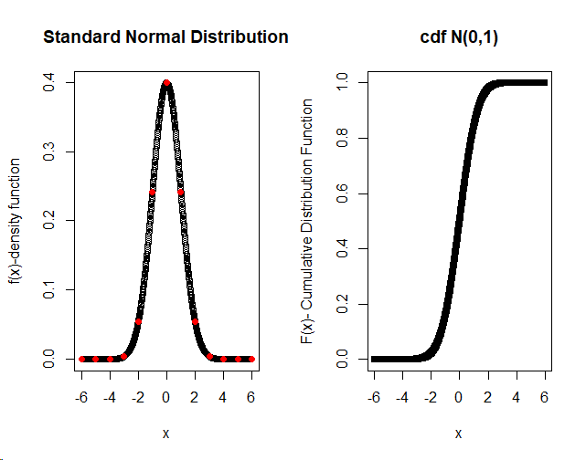
RESULT -
- Values of a continuous random variable x are generated in an interval (-6,6) and simultaneously their pdfs and cdfs are generated using dnorm() and pnorm() functions respectively.
- Further, a density curve is obtained by plotting values of x against their pdfs f(x) and similarly distribution function is plotted using values of x and their corresponding cdfs

PRACTICAL – 9

AIM - To draw random numbers from the given distributions and plot their pdfs and cdfs.
PROBLEM - Draw the random numbers of size 25 from the given pdf/pmf given below. Also, plot the pdf (probability density function) and cdf (cumulative distribution function) of the following continuous/ discrete distributions.
- Binomial with size=60, prob=0.3, 0.5, 0.9.
- Poisson 𝜆 = 2, 5, 10
- Gamma distribution
- Standard cauchy distribution
- Weibull distribution

Prepare a theory sheet consisting of the form of the pdf/pmf and cdf of the above said distribution. In each plot give the x-axis, y-axis, and main title. Use par with mfrow function to adjust the figures.

THEORY & METHODOLOGY USED - The pdfs/pmfs f(x)/p(x) and cdfs F(x) of the given distributions are defined as:
- Binomial Distribution: $P\left(X=x\right)=\left(n x \right)p^{x}{(1-p)}^{n-x}$ ; x=0,1,2,…,n
$F\left(x\right)=P\left(X≤x\right)=\sum_{k=0}^{x}{}\left(n k \right)p^{k}{(1-p)}^{n-k}$
- Poisson Distribution: $P\left(X=x\right)=\frac{e^{-λ}λ^{x}}{x!}$ ; x=0,1,2,…
$F\left(x\right)=P\left(X≤x\right)=\sum_{k=0}^{x}{}\frac{e^{-λ}λ^{k}}{k!}$
- Gamma Distribution: $f\left(x\right)=\frac{x^{α-1}e^{-\frac{x}{β}}}{β^{α}γ(α)}$ ; x>0
$F\left(x\right)=\int_{0}^{x}{}\frac{t^{α-1}e^{-\frac{t}{β}}}{β^{α}γ(α)}dt$
- Standard Cauchy Distribution: $f\left(x\right)=\frac{1}{π(1+x^{2})}$ ; -ꝏ<x<ꝏ
$F\left(x\right)=\int_{-∞}^{x}{}\frac{1}{π(1+t^{2})}dt$
- Weibull Distribution: $f\left(x\right)=\frac{c}{α}{\left(\frac{x}{α}\right)}^{c-1}exp\left\{-{\left(\frac{x}{α}\right)}^{c}\right\}$ ; x>0
$F\left(x\right)=1-exp\left\{-{\left(\frac{x}{α}\right)}^{c}\right\}$
CODE & OUTPUT –

i. > #Drawing random numbers of size 25 from Bin(60,0.3), Bin(60,0.5) and Bin(60,0.9).
> rbinom(n=25,size=60,prob=0.3)
[1] 20 13 16 17 11 17 20 16 16 21 23 17 19 18 17 19 14 24 16 15 15 26 17 13 22
> rbinom(n=25,size=60,prob=0.5)
[1] 33 31 27 31 36 28 27 23 35 31 29 26 20 36 23 31 29 34 33 30 26 27 27 26 31
> rbinom(n=25,size=60,prob=0.9)
[1] 56 53 55 52 57 56 56 54 54 54 54 55 53 55 56 57 54 55 54 53 56 50 51 58 52

> #Plotting the pdf and cdf of Bin(60,0.3), Bin(60,0.5) and Bin(60,0.9).
> x=seq(from=0,to=60)
> par(mfrow=c(3,2))

> #When p=0.3;
> y1=dbinom(x,60,0.3)
> z1=pbinom(x,60,0.3)
>plot(x,y1,type="h",main="pmf of B(60,0.3)",xlab="x-values",ylab="p(x)-probability mass function")
> plot(x,z1,type="s",main="cdf of B(60,0.3)",xlab="x-values",ylab="F(x)-distribution function")
> #When p=0.5;
> y2=dbinom(x,60,0.5)
> z2=pbinom(x,60,0.5)
>plot(x,y2,type="h",main="pmf of B(60,0.5)",xlab="x-values",ylab="p(x)-probability mass function")
> plot(x,z2,type="s",main="cdf of B(60,0.5)",xlab="x-values",ylab="F(x)-distribution function")
> #When p=0.9;
> y3=dbinom(x,60,0.9)
> z3=pbinom(x,60,0.9)
>plot(x,y3,type="h",main="pmf of B(60,0.9)",xlab="x-values",ylab="p(x)-probability mass function")
> plot(x,z3,type="s",main="cdf of B(60,0.9)",xlab="x-values",ylab="F(x)-distribution function")

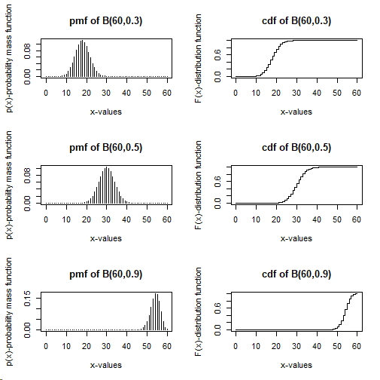
ii. > #Drawing random numbers of size 25 from Pois(2), Pois(5) and Pois(10).
> rpois(n=25,lambda=2)
[1] 3 1 2 1 2 4 3 3 3 0 2 1 6 3 2 1 2 4 1 2 2 2 1 0 1
> rpois(n=25,lambda=5)
[1] 5 5 8 4 4 5 5 2 4 7 8 3 5 9 6 4 4 2 6 4 6 4 3 5 7
> rpois(n=25,lambda=10)
[1] 8 10 9 13 8 13 11 16 11 8 6 10 5 14 6 10 12 9 15 10 12 15 12 12 8
> #Plotting the pdf and cdf of Pois(2), Pois(5) and Pois(10).
> x=seq(from=0,to=40)
> par(mfrow=c(3,2))
> #When lambda=2;
> y1=dpois(x,2)
> z1=ppois(x,2)
>plot(x,y1,type="h",main="pmf of Pois(2)",xlab="x-values",ylab="P(X=x)-Probability Mass Function")
> plot(x,z1,type="s",main="cdf of Pois(2)",xlab="x-values",ylab="F(X=x)-Distribution Function")
> #When lambda=5;
> y2=dpois(x,5)
> z2=ppois(x,5)
>plot(x,y2,type="h",main="pmf of Pois(5)",xlab="x-values",ylab="P(X=x)-Probability Mass Function")
> plot(x,z2,type="s",main="cdf of Pois(5)",xlab="x-values",ylab="F(X=x)-Distribution Function")
> #When lambda=10;
> y3=dpois(x,10)
> z3=ppois(x,10)
>plot(x,y3,type="h",main="pmf of Pois(10)",xlab="x-values",ylab="P(X=x)-Probability Mass Function")
> plot(x,z3,type="s",main="cdf of Pois(10)",xlab="x-values",ylab="F(X=x)-Distribution Function")

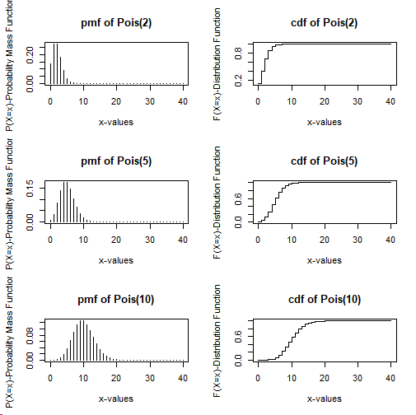
iii. > #Drawing random numbers of size 25 from Gamma Distribution.
> rgamma(25,shape=1,scale=2)
[1] 1.75152528 1.13167369 0.61771067 2.91425599 0.24646215 1.83487164
[7] 0.05432213 1.98380717 0.17021439 0.19232372 1.56602556 0.68070437
[13] 0.84610223 6.14906931 0.94211819 1.62581690 6.14233366 3.77394750
[19] 0.66104295 0.77713247 0.42501091 4.12825765 1.91489075 2.69085209
[25] 2.40750097
> #Plotting the pdf and cdf of Gamma Distribution.
> x=seq(from=0,to=50,length.out=1000)
> par(mfrow=c(1,2))
> y=dgamma(x,shape=1,scale=2)
> z=pgamma(x,shape=1,scale=2)
> plot(x,y,type="h",main="pdf of Gamma(1,2)",xlab="x-values",ylab="f(x)-probability density function")
> plot(x,z,type="s",main="cdf of Gamma(1,2)",xlab="x-values",ylab="F(x)-Cumulative distribution function")
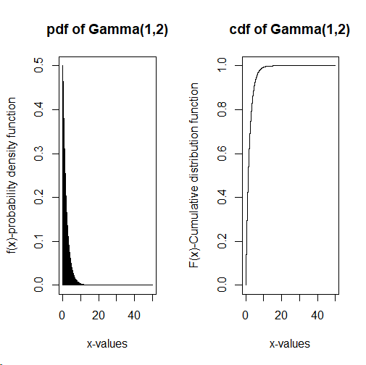

iv. > #Drawing random numbers of size 25 from Standard cauchy distribution.
> par(mfrow=c(1,2))
> rcauchy(n=25,location=0,scale=1)
[1] 0.524247622 -3.504266449 0.344520883 -2.322314189 1.437893690
[6] -3.930962030 1.403141464 -21.022070965 -0.122380319 0.411328861
[11] -0.004160994 -0.207521885 2.879347937 0.289563854 0.869940778
[16] -1.080738850 0.949676885 0.814653846 0.312792871 0.952059091
[21] 1.833353487 -1.734480016 -0.559749342 -28.074346841 -2.639325278
> #Plotting the pdf and cdf of Standard cauchy distribution.
> x=seq(from=0,to=80,length.out=500)
> y=dcauchy(x,location=0,scale=1)
> z=pcauchy(x,location=0,scale=1)
> plot(x,y,type="h",main="pdf of standard cauchy distribution",ylab="f(x)-probability density function",xlab="x-values")
> plot(x,z,type="s",main="cdf of standard cauchy distribution",ylab="F(x)-Cumulative distribution function",xlab="x-values")
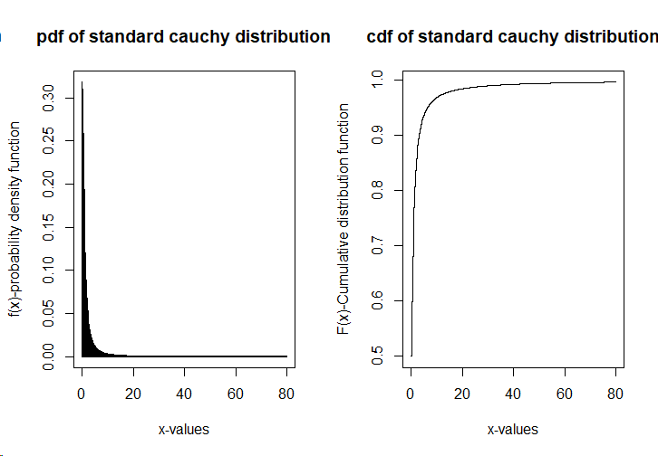

v. > #Drawing random numbers of size 25 from Weibull distribution.
> rweibull(n=25,shape=2,scale=1)
[1] 1.2609592 0.7369844 1.4894100 0.6710592 0.8235224 1.5957769 0.5677536
[8] 0.9813618 0.8951687 1.1263602 0.4721516 0.5314234 1.2806841 1.4494414
[15] 2.2618490 1.5827286 1.4932054 0.3076141 1.2028326 1.3640806 0.5624922
[22] 0.4466436 0.3710409 1.7105026 1.7911404
> #Plotting the pdf and cdf of Weibull distribution.
> par(mfrow=c(1,2))
> x=seq(from=0,to=20,length.out=500)
> y=dweibull(x,shape=2,scale=1)
> z=pweibull(x,shape=2,scale=1)
> plot(x,y,type="h",main="pdf of Weibull distribution",ylab="f(x)-probability density function",xlab="x-values")
> plot(x,z,type="s",main="cdf of Weibull distribution",ylab="F(x)-Cumulative distribution function",xlab="x-values")
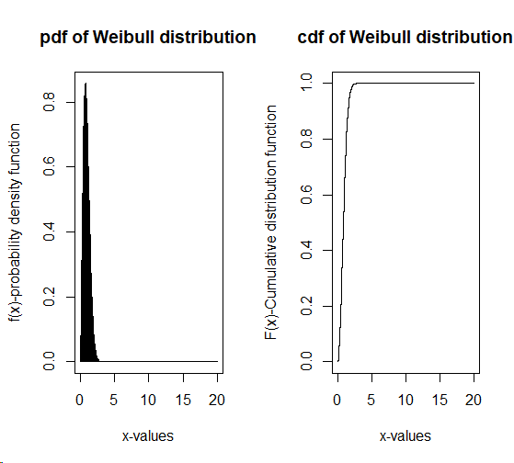
RESULT :- We obtain the following results:
Random numbers of size 25 are drawn from each of the given distributions using functions such as rbinom(), rgamma(), rpois(), rcauchy() and rweibull().
Pdf/pmf and cdf of each of the given distributions are also plotted above.

PRACTICAL – 10

AIM - Working with data frame.
PROBLEM - Create a data frame using the following data for some 20 vegetables at a supermarket sold in a month. The names of the vegetables (in order) are as follows:
Eggplant, Pea, Cucumber, Potato, Pumpkin, Lettuce, Tomato, Sweet potato, Mushroom, Green bean, Corn, Cauliflower, Beetroot, Bell pepper, Broccoli, Celery, Cabbage, Carrot, Onion, Lady figure.
Perform the following:
- Add these names, as the row names of the above data frame.
- Calculate the revenue for each vegetable and its proportion in the total revenue.
- Add the label ‘green’ where 1 is written and the label ‘other. color’, where 2 is written.
- Calculate the difference between ‘green’ color vegetables ‘other. color’ vegetables revenues.
- Replace the label ‘other. color’ by ‘not. green’.
- Extract all the rows where ‘not. green’ is appearing.

Sl. No. | Sales  (Kg) | Price/Kg | Color.flag | Sl. No. | Sales  (Kg) | Price/Kg | Color.flag
1 | 200 | 40 | 2 | 11 | 500 | 40 | 2
2 | 100 | 80 | 1 | 12 | 185 | 60 | 1
3 | 100 | 40 | 1 | 13 | 200 | 100 | 2
4 | 400 | 60 | 2 | 14 | 150 | 65 | 2
5 | 500 | 70 | 2 | 15 | 240 | 45 | 1
6 | 800 | 90 | 1 | 16 | 500 | 60 | 1
7 | 150 | 40 | 2 | 17 | 250 | 65 | 1
8 | 200 | 90 | 2 | 18 | 170 | 35 | 2
9 | 120 | 30 | 2 | 19 | 350 | 85 | 2
10 | 400 | 30 | 1 | 20 | 180 | 60 | 1

THEORY & METHODOLOGY USED - We have used the function data.frame() to create a data frame with multiple columns.
rownames() function is used for giving rownames to the given data frame.
$ symbol is used while accessing any column of a data frame.
ifelse() function is used for giving labels in the Color.flag column whose syntax is:
ifelse (condition, value if condition is true, value if condition is false)
sum() function is used for finding the sum of the values (satisfying a particular condition) of any column in a data frame.

CODE & OUTPUT –

> #Creating a data frame.
> SI_No=seq(from=1,to=20)
> Sales_Kg=c(200,100,100,400,500,800,150,200,120,400,500,185,200,150,240,500,250,170,350,180)
> PricePerKg=c(40,80,40,60,70,90,40,90,30,30,40,60,100,65,45,60,65,35,85,60)
> Color_flag=c(2,1,1,2,2,1,2,2,2,1,2,1,2,2,1,1,1,2,2,1)
> Veg_df=data.frame(SI_No,Sales_Kg,PricePerKg,Color_flag)
> Veg_df
SI_No Sales_Kg PricePerKg Color_flag
1 1 200 40 2
2 2 100 80 1
3 3 100 40 1
4 4 400 60 2
5 5 500 70 2
6 6 800 90 1
7 7 150 40 2
8 8 200 90 2
9 9 120 30 2
10 10 400 30 1
11 11 500 40 2
12 12 185 60 1
13 13 200 100 2
14 14 150 65 2
15 15 240 45 1
16 16 500 60 1
17 17 250 65 1
18 18 170 35 2
19 19 350 85 2
20 20 180 60 1

1. > #Adding rownames for the dataframe.
> rownames(Veg_df)=c('Eggplant','Pea','Cucumber','Potato','Pumpkin','Lettuce','Tomato','Sweet potato','Mushroom','Green bean','Corn','Cauliflower','Beetroot','Bell pepper','Broccoli','Celery','Cabbage','Carrot','Onion','Lady finger')
> Veg_df
SI_No Sales_Kg PricePerKg Color_flag
Eggplant 1 200 40 2
Pea 2 100 80 1
Cucumber 3 100 40 1
Potato 4 400 60 2
Pumpkin 5 500 70 2
Lettuce 6 800 90 1
Tomato 7 150 40 2
Sweet potato 8 200 90 2
Mushroom 9 120 30 2
Green bean 10 400 30 1
Corn 11 500 40 2
Cauliflower 12 185 60 1
Beetroot 13 200 100 2
Bell pepper 14 150 65 2
Broccoli 15 240 45 1
Celery 16 500 60 1
Cabbage 17 250 65 1
Carrot 18 170 35 2
Onion 19 350 85 2
Lady finger 20 180 60 1

2. > #Calculating the revenue for each vegetable and its proportion in the total revenue.
> Veg_df$Revenue=Veg_df$Sales_Kg*Veg_df$PricePerKg
> Veg_df
SI_No Sales_Kg PricePerKg Color_flag Revenue
Eggplant 1 200 40 2 8000
Pea 2 100 80 1 8000
Cucumber 3 100 40 1 4000
Potato 4 400 60 2 24000
Pumpkin 5 500 70 2 35000
Lettuce 6 800 90 1 72000
Tomato 7 150 40 2 6000
Sweet potato 8 200 90 2 18000
Mushroom 9 120 30 2 3600
Green bean 10 400 30 1 12000
Corn 11 500 40 2 20000
Cauliflower 12 185 60 1 11100
Beetroot 13 200 100 2 20000
Bell pepper 14 150 65 2 9750
Broccoli 15 240 45 1 10800
Celery 16 500 60 1 30000
Cabbage 17 250 65 1 16250
Carrot 18 170 35 2 5950
Onion 19 350 85 2 29750
Lady finger 20 180 60 1 10800
> TotRev=sum(Veg_df$Revenue)
> TotRev
[1] 355000
> Veg_df$PercentProp_TotRev=(Veg_df$Revenue/TotRev)*100
> Veg_df
SI_No Sales_Kg PricePerKg Color_flag Revenue PercentProp_TotRev
Eggplant 1 200 40 2 8000 2.253521
Pea 2 100 80 1 8000 2.253521
Cucumber 3 100 40 1 4000 1.126761
Potato 4 400 60 2 24000 6.760563
Pumpkin 5 500 70 2 35000 9.859155
Lettuce 6 800 90 1 72000 20.281690
Tomato 7 150 40 2 6000 1.690141
Sweet potato 8 200 90 2 18000 5.070423
Mushroom 9 120 30 2 3600 1.014085
Green bean 10 400 30 1 12000 3.380282
Corn 11 500 40 2 20000 5.633803
Cauliflower 12 185 60 1 11100 3.126761
Beetroot 13 200 100 2 20000 5.633803
Bell pepper 14 150 65 2 9750 2.746479
Broccoli 15 240 45 1 10800 3.042254
Celery 16 500 60 1 30000 8.450704
Cabbage 17 250 65 1 16250 4.577465
Carrot 18 170 35 2 5950 1.676056
Onion 19 350 85 2 29750 8.380282
Lady finger 20 180 60 1 10800 3.042254

3. > #Adding the labels in Color flag.
> Veg_df$Color_flag=ifelse(Veg_df$Color_flag==1,'green','other.color')
> Veg_df
SI_No Sales_Kg PricePerKg Color_flag Revenue PercentProp_TotRev
Eggplant 1 200 40 other.color 8000 2.253521
Pea 2 100 80 green 8000 2.253521
Cucumber 3 100 40 green 4000 1.126761
Potato 4 400 60 other.color 24000 6.760563
Pumpkin 5 500 70 other.color 35000 9.859155
Lettuce 6 800 90 green 72000 20.281690
Tomato 7 150 40 other.color 6000 1.690141
Sweet potato 8 200 90 other.color 18000 5.070423
Mushroom 9 120 30 other.color 3600 1.014085
Green bean 10 400 30 green 12000 3.380282
Corn 11 500 40 other.color 20000 5.633803
Cauliflower 12 185 60 green 11100 3.126761
Beetroot 13 200 100 other.color 20000 5.633803
Bell pepper 14 150 65 other.color 9750 2.746479
Broccoli 15 240 45 green 10800 3.042254
Celery 16 500 60 green 30000 8.450704
Cabbage 17 250 65 green 16250 4.577465
Carrot 18 170 35 other.color 5950 1.676056
Onion 19 350 85 other.color 29750 8.380282
Lady finger 20 180 60 green 10800 3.042254

4. > #Calculating the difference in revenues.
> green_rev=sum(Veg_df$Revenue[Veg_df$Color_flag=='green'])
> green_rev
[1] 174950
> OthCol_rev=sum(Veg_df$Revenue[Veg_df$Color_flag=='other.color'])
> OthCol_rev
[1] 180050
> rev_diff=green_rev-OthCol_rev
> rev_diff
[1] -5100

5. > #Replacing the label.
> Veg_df$Color_flag[Veg_df$Color_flag=='other.color']='not.green'
> Veg_df
SI_No Sales_Kg PricePerKg Color_flag Revenue PercentProp_TotRev
Eggplant 1 200 40 not.green 8000 2.253521
Pea 2 100 80 green 8000 2.253521
Cucumber 3 100 40 green 4000 1.126761
Potato 4 400 60 not.green 24000 6.760563
Pumpkin 5 500 70 not.green 35000 9.859155
Lettuce 6 800 90 green 72000 20.281690
Tomato 7 150 40 not.green 6000 1.690141
Sweet potato 8 200 90 not.green 18000 5.070423
Mushroom 9 120 30 not.green 3600 1.014085
Green bean 10 400 30 green 12000 3.380282
Corn 11 500 40 not.green 20000 5.633803
Cauliflower 12 185 60 green 11100 3.126761
Beetroot 13 200 100 not.green 20000 5.633803
Bell pepper 14 150 65 not.green 9750 2.746479
Broccoli 15 240 45 green 10800 3.042254
Celery 16 500 60 green 30000 8.450704
Cabbage 17 250 65 green 16250 4.577465
Carrot 18 170 35 not.green 5950 1.676056
Onion 19 350 85 not.green 29750 8.380282
Lady finger 20 180 60 green 10800 3.042254

6. > #Extracting the 'not.green' rows.
> Veg_df[Veg_df$Color_flag=='not.green',]
SI_No Sales_Kg PricePerKg Color_flag Revenue PercentProp_TotRev
Eggplant 1 200 40 not.green 8000 2.253521
Potato 4 400 60 not.green 24000 6.760563
Pumpkin 5 500 70 not.green 35000 9.859155
Tomato 7 150 40 not.green 6000 1.690141
Sweet potato 8 200 90 not.green 18000 5.070423
Mushroom 9 120 30 not.green 3600 1.014085
Corn 11 500 40 not.green 20000 5.633803
Beetroot 13 200 100 not.green 20000 5.633803
Bell pepper 14 150 65 not.green 9750 2.746479
Carrot 18 170 35 not.green 5950 1.676056
Onion 19 350 85 not.green 29750 8.380282
RESULT -
- After calculating the revenue for each vegetable, we observe that the highest revenue was made from the vegetable ‘Lettuce’ thus making its %age proportion in the total revenue to be 20.28% and the lowest revenue was made from the vegetable ‘Mushroom’ with the 5age proportion in total revenue as 1.01%.
- Total revenue made out of selling the given vegetables = 3,55,000 Rs.
- Revenue made out of selling green color vegetables = 1,74,950 Rs.
- Revenue made out of selling other color vegetables = 1,80,050 Rs.
- Thus, making the difference between their revenues to be of 5,100 Rs. which also shows that revenue made from other color vegetables is more than that of green color vegetables.

PRACTICAL – 11

AIM - Working with loops and in-built functions.
PROBLEM - Load the built -in R data set 𝑈𝑆𝐴𝑟𝑟e𝑠𝑡𝑠 as a data frame and perform the following tasks:
- Use fo𝑟 loop, wℎi𝑙e loop and 𝑟e𝑝e𝑎𝑡 loop to calculate the total Murder, total Assault, total Rape in the 𝑈𝑆𝐴𝑟𝑟e𝑠𝑡𝑠 data set. Also, use 𝑅 functions to calculate the quantities as mentioned above and verify your answers.
- Use 𝑛e𝑥𝑡 function to extract all those rows of the 𝑈𝑆𝐴𝑟𝑟e𝑠𝑡𝑠 data set, for which Murder is more than 22 and less than 10.
- Use the 𝑎𝑝𝑝𝑙𝑦 function to calculate the row sums, column sums, row average and column averages, respectively.

THEORY & METHODOLOGY USED - head() function in R returns the first 6 rows of the dataset.
$ symbol is used for accessing any column of a data frame.
nrow() function helps in counting the number of rows in a data frame.
We have used ‘for’, ‘while’ and ‘repeat’ loops for finding the total number of murders, assaults and rapes for the given data. Thereafter, to verify our results we made use of sum() function which calculates the sum of all the values in a column of a dataframe.
cat() is used to produce the output on the screen.
next statement in R is used to skip any remaining statements in the loop and continue the execution of the program. In other words, it is a statement that skips the current iteration without loop termination.
The apply() function lets us apply a function to the rows or columns of a matrix or data frame. This function takes matrix or data frame as an argument along with function and whether it has to be applied by row or column and returns the result in the form of a vector or array or list of values obtained.

CODE & OUTPUT -
> #Loading the USArrests dataset.
> data=USArrests
> head(data)
Murder Assault UrbanPop Rape
Alabama 13.2 236 58 21.2
Alaska 10.0 263 48 44.5
Arizona 8.1 294 80 31.0
Arkansas 8.8 190 50 19.5
California 9.0 276 91 40.6
Colorado 7.9 204 78 38.7

(i). > #Using 'for' loop to calculate total murder, assault and rape.
> murder=data$Murder
> murder
[1] 13.2 10.0 8.1 8.8 9.0 7.9 3.3 5.9 15.4 17.4 5.3 2.6 10.4 7.2 2.2
[16] 6.0 9.7 15.4 2.1 11.3 4.4 12.1 2.7 16.1 9.0 6.0 4.3 12.2 2.1 7.4
[31] 11.4 11.1 13.0 0.8 7.3 6.6 4.9 6.3 3.4 14.4 3.8 13.2 12.7 3.2 2.2
[46] 8.5 4.0 5.7 2.6 6.8
> assault=data$Assault
> assault
[1] 236 263 294 190 276 204 110 238 335 211 46 120 249 113 56 115 109 249 83
[20] 300 149 255 72 259 178 109 102 252 57 159 285 254 337 45 120 151 159 106
[39] 174 279 86 188 201 120 48 156 145 81 53 161
> rape=data$Rape
> rape
[1] 21.2 44.5 31.0 19.5 40.6 38.7 11.1 15.8 31.9 25.8 20.2 14.2 24.0 21.0 11.3
[16] 18.0 16.3 22.2 7.8 27.8 16.3 35.1 14.9 17.1 28.2 16.4 16.5 46.0 9.5 18.8
[31] 32.1 26.1 16.1 7.3 21.4 20.0 29.3 14.9 8.3 22.5 12.8 26.9 25.5 22.9 11.2
[46] 20.7 26.2 9.3 10.8 15.6
> s1=s2=s3=0
> for(i in 1:nrow(data))
+ {
+ s1=s1+murder[i]
+ s2=s2+assault[i]
+ s3=s3+rape[i]
+ }
> cat("Total number of murders: ",s1,"\n")
Total number of murders: 389.4
> cat("Total number of assaults: ",s2,"\n")
Total number of assaults: 8538
> cat("Total number of rapes: ",s3,"\n")
Total number of rapes: 1061.6
> #Using 'while' loop to calculate total murder, assault and rape.
> s1=s2=s3=0
> i=1
> while(i<=nrow(data))
+ {
+ s1=s1+murder[i]
+ s2=s2+assault[i]
+ s3=s3+rape[i]
+ i=i+1
+ }
> cat("Total number of murders: ",s1,"\n")
Total number of murders: 389.4
> cat("Total number of assaults: ",s2,"\n")
Total number of assaults: 8538
> cat("Total number of rapes: ",s3,"\n")
Total number of rapes: 1061.6
> #Using 'repeat' loop to calculate total murder, assault and rape.
> s1=s2=s3=0
> i=1
> repeat
+ {
+ s1=s1+murder[i]
+ s2=s2+assault[i]
+ s3=s3+rape[i]
+ i=i+1
+ if(i>length(murder))
+ {
+ break
+ }
+ }
> cat("Total number of murders: ",s1,"\n")
Total number of murders: 389.4
> cat("Total number of assaults: ",s2,"\n")
Total number of assaults: 8538
> cat("Total number of rapes: ",s3,"\n")
Total number of rapes: 1061.6
> #Using R functions to verify the answers.
> Tot_murder=sum(murder)
> Tot_murder
[1] 389.4
> Tot_assault=sum(assault)
> Tot_assault
[1] 8538
> Tot_rape=sum(rape)
> Tot_rape
[1] 1061.6

(ii). > #Using 'next' function extract only the specified rows.
> subset=data.frame()
> for(i in 1:nrow(data))
+ {
+ if(murder[i]>22)
+ {
+ next
+ }
+ else if(murder[i]<10)
+ {
+ subset=rbind(subset,data[i,])
+ }
+ }
> subset
Murder Assault UrbanPop Rape
Arizona 8.1 294 80 31.0
Arkansas 8.8 190 50 19.5
California 9.0 276 91 40.6
Colorado 7.9 204 78 38.7
Connecticut 3.3 110 77 11.1
Delaware 5.9 238 72 15.8
Hawaii 5.3 46 83 20.2
Idaho 2.6 120 54 14.2
Indiana 7.2 113 65 21.0
Iowa 2.2 56 57 11.3
Kansas 6.0 115 66 18.0
Kentucky 9.7 109 52 16.3
Maine 2.1 83 51 7.8
Massachusetts 4.4 149 85 16.3
Minnesota 2.7 72 66 14.9
Missouri 9.0 178 70 28.2
Montana 6.0 109 53 16.4
Nebraska 4.3 102 62 16.5
New Hampshire 2.1 57 56 9.5
New Jersey 7.4 159 89 18.8
North Dakota 0.8 45 44 7.3
Ohio 7.3 120 75 21.4
Oklahoma 6.6 151 68 20.0
Oregon 4.9 159 67 29.3
Pennsylvania 6.3 106 72 14.9
Rhode Island 3.4 174 87 8.3
South Dakota 3.8 86 45 12.8
Utah 3.2 120 80 22.9
Vermont 2.2 48 32 11.2
Virginia 8.5 156 63 20.7
Washington 4.0 145 73 26.2
West Virginia 5.7 81 39 9.3
Wisconsin 2.6 53 66 10.8
Wyoming 6.8 161 60 15.6

(iii). > #Using 'apply' function to calculate row/column sums and averages.
> row_sums=apply(data,1,sum)
> row_sums
Alabama Alaska Arizona Arkansas California
328.4 365.5 413.1 268.3 416.6
Colorado Connecticut Delaware Florida Georgia
328.6 201.4 331.7 462.3 314.2
Hawaii Idaho Illinois Indiana Iowa
154.5 190.8 366.4 206.2 126.5
Kansas Kentucky Louisiana Maine Maryland
205.0 187.0 352.6 143.9 406.1
Massachusetts Michigan Minnesota Mississippi Missouri
254.7 376.2 155.6 336.2 285.2
Montana Nebraska Nevada New Hampshire New Jersey
184.4 184.8 391.2 124.6 274.2
New Mexico New York North Carolina North Dakota Ohio
398.5 377.2 411.1 97.1 223.7
Oklahoma Oregon Pennsylvania Rhode Island South Carolina
245.6 260.2 199.2 272.7 363.9
South Dakota Tennessee Texas Utah Vermont
147.6 287.1 319.2 226.1 93.4
Virginia Washington West Virginia Wisconsin Wyoming
248.2 248.2 135.0 132.4 243.4
> col_sums=apply(data,2,sum)
> col_sums
Murder Assault UrbanPop Rape
389.4 8538.0 3277.0 1061.6
> row_avg=apply(data,1,mean)
> row_avg
Alabama Alaska Arizona Arkansas California
82.100 91.375 103.275 67.075 104.150
Colorado Connecticut Delaware Florida Georgia
82.150 50.350 82.925 115.575 78.550
Hawaii Idaho Illinois Indiana Iowa
38.625 47.700 91.600 51.550 31.625
Kansas Kentucky Louisiana Maine Maryland
51.250 46.750 88.150 35.975 101.525
Massachusetts Michigan Minnesota Mississippi Missouri
63.675 94.050 38.900 84.050 71.300
Montana Nebraska Nevada New Hampshire New Jersey
46.100 46.200 97.800 31.150 68.550
New Mexico New York North Carolina North Dakota Ohio
99.625 94.300 102.775 24.275 55.925
Oklahoma Oregon Pennsylvania Rhode Island South Carolina
61.400 65.050 49.800 68.175 90.975
South Dakota Tennessee Texas Utah Vermont
36.900 71.775 79.800 56.525 23.350
Virginia Washington West Virginia Wisconsin Wyoming
62.050 62.050 33.750 33.100 60.850
> col_avg=apply(data,2,mean)
> col_avg
Murder Assault UrbanPop Rape
7.788 170.760 65.540 21.232

RESULT -
- After applying the ‘for’, ‘while’ and ‘repeat’ loops, we found that
- Total Murder = 389.4
- Total Assault = 8538
- Total Rape = 1061.6
- These results are verified using in-built function sum() for finding the column total.
- We have extracted 34 rows from the USArrests data where murder is more than 22 and less than 10.
- After using the apply function we have found the row sums, column sums, row averages and column averages as displayed above in the output.

PRACTICAL – 12

AIM - To find the MLE of gamma and exponential distribution and plot their log-likelihood.
PROBLEM - (a) Obtain the MLE of gamma distribution with shape=3 and scale =2. Also plot the log
likelihood to verify your result.
(b) Obtain the MLE of exponential distribution with lambda=2.5. Also, plot the log-
likelihood to verify your result.
THEORY & METHODOLOGY USED - (a) The pdf of Gamma distribution is given by:
$f\left(x\right)=\frac{x^{α-1}e^{-\frac{x}{β}}}{β^{α}γ(α)}$ ; x>0
MLE of scale parameter β is found to be : $β_{MLE}=\frac{\sum_{i}{}x_{i}}{nα}$
where, log-likelihood is given by: $loglog L =\left(α-1\right)\sum_{i}{}loglog x_{i} -\frac{\sum_{i}{}x_{i}}{β}-n αloglog β -nloglog γ(α)$
(b) The pdf of Exponential distribution is given by: $f\left(x\right)=λe^{-λx}$ ; x>0
MLE of parameter λ is found to be: $λ_{MLE}=\frac{n}{\sum_{i}{}x_{i}}$
where, log-likelihood is given by: $loglog L =nloglog λ -λ \sum_{i}{}x_{i}$

CODE & OUTPUT -

(a) > rv=rgamma(100,shape=3,scale=2)
> s=sum(rv)
> true_shape=3
> true_scale=2
> n=100
> #Finding the MLE of gamma distribution.
> mle_scale=s/(n*true_shape)
> cat("MLE of scale parameter: ",mle_scale,"\n")
MLE of scale parameter: 1.917102
> #Plotting the log-likelihood of gamma distribution.
> scale_val=seq(from=0.1,to=10,by=0.1)
> log_likelihood=((true_shape-1)*sum(log(rv)))-(s/scale_val)-(n*true_shape*log(scale_val))-(n*lgamma(true_shape))
> plot(scale_val,log_likelihood,type="l",xlab="Scale Parameter",ylab="Log Likelihood",main="Log Likelihood for Scale Parameter")
> abline(v=mle_scale,col="red",lty=2)

(b) > rv=rexp(n=100,rate = 2.5)
> s=sum(rv)
> true_lambda=2.5
> n=100
> #Finding the MLE of exponential distribution.
> mle_lambda=n/s
> cat("MLE of lambda: ",mle_lambda,"\n")
MLE of lambda: 2.461891
> #Plotting the log likelihood of exponential distribution.
> lambda_val=seq(0.1,10,by = 0.1)
> log_likelihood=(n*log(lambda_val))-(lambda_val*s)
> plot(lambda_val,log_likelihood,type="l",xlab="Lambda",ylab="Log Likelihood",main="Log Likelihood for Lambda")
> abline(v=mle_lambda,col="red",lty=2)
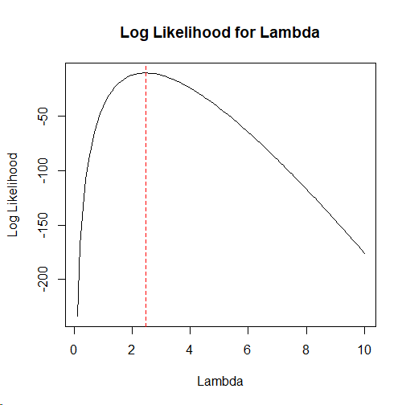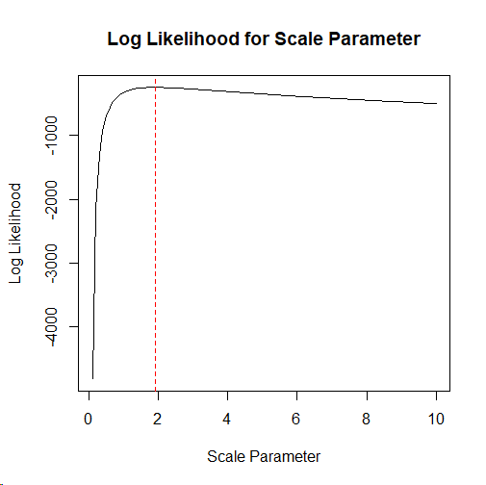
RESULT -
- MLE of scale parameter of the given gamma distribution is calculated as: 1.9171 (approx. 2). And also, log-likelihood is plotted above to verify this result.
- MLE of the parameter of the given exponential distribution is calculated as: 2.4619 (approx. 2.5). Similarly, here also the log-likelihood is plotted to verify the obtained result.

